CODING ASSESSMENT – MONGODB (25/07/2025)
use db
>> One-to-One Relationship – Embedded Document
Insert:
db.student.insertOne({
StudentName: "GeeksA",
StudentId: "g_f_g_1209",
Branch: "CSE",
PermanentAddress: {
Address: "XXXXX",
City: "Delhi",
PinCode: 202333
}
});

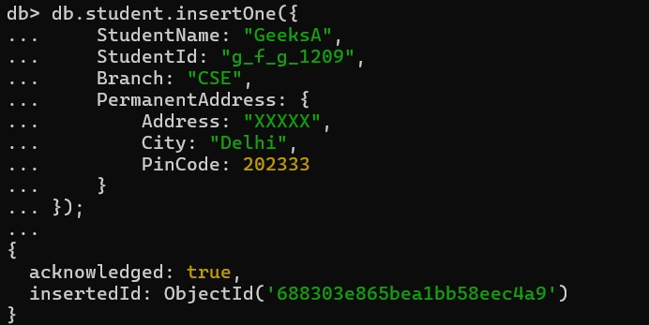

Query:
db.student.find({ StudentName: "GeeksA" }, { "PermanentAddress.Address": 1 }).pretty();
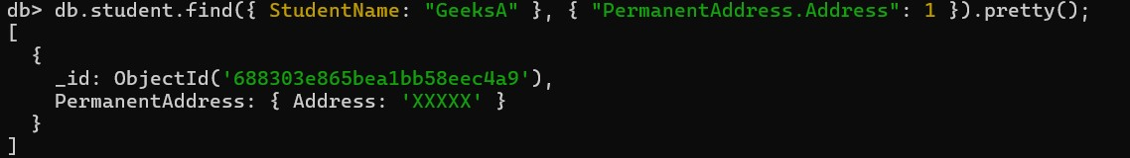

>> One-to-Many Relationship – Embedded Documents
Insert:
db.student.insertOne({
StudentName: "GeeksA",
StudentId: "g_f_g_1209",
Branch: "CSE",
Address: [
{
Type: "Permanent",
Address: "XXXXX",
City: "Delhi",
PinCode: 202333
},
{
Type: "Current",
Address: "YYYYY",
City: "Mumbai",
PinCode: 334509
}
]
});
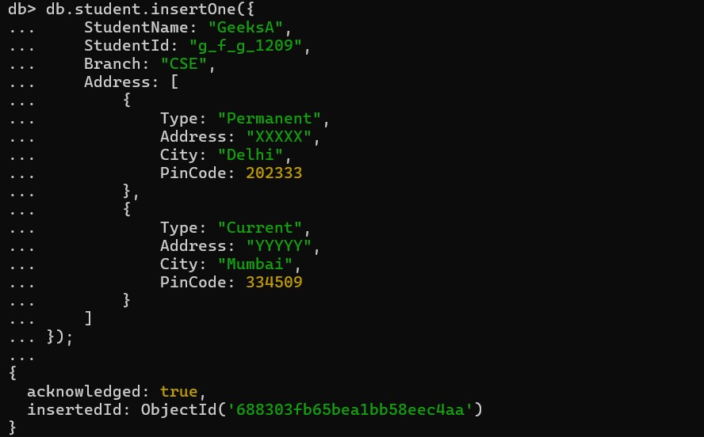

Query:
db.student.find({ StudentName: "GeeksA" }, { "Address.Address": 1 }).pretty();
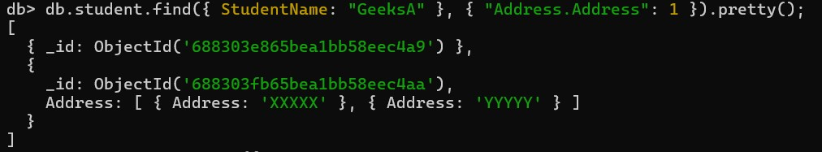
>> One-to-Many Relationship – Reference Model
Insert (Separate Collections):
db.teacher.insertOne({
teacherName: "Sunita",
TeacherId: "g_f_g_1209",
classIds: ["C_123", "C_234"]
});

db.class.insertMany([
{
ClassId: "C_123",
TeacherId: "g_f_g_1209",
ClassName: "GeeksA",
Studentcount: 23,
Subject: "Science"
},
{
ClassId: "C_234",
TeacherId: "g_f_g_1209",
ClassName: "GeeksB",
Studentcount: 33,
Subject: "Maths"
}
]);
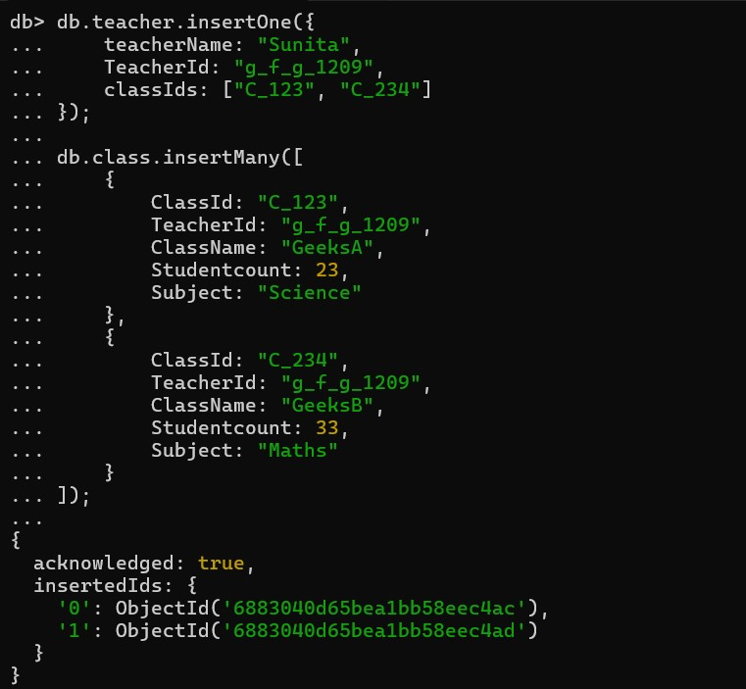
Query:
db.teacher.find({ teacherName: "Sunita" }, { classIds: 1 });
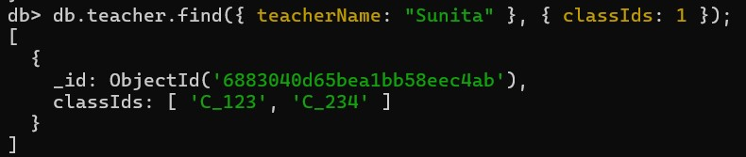
You can manually use classIds to query classes:
db.class.find({ ClassId: { $in: ["C_123", "C_234"] } });
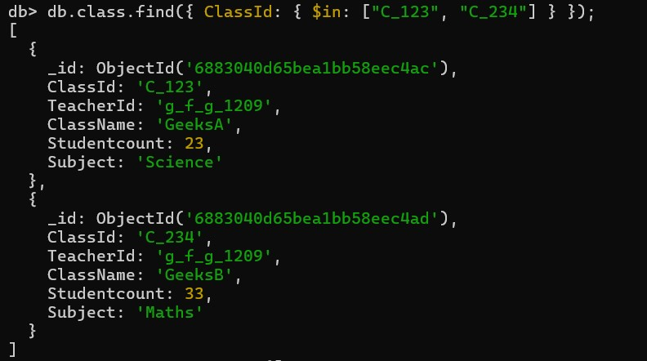
>> Many-to-Many Relationship – Using $lookup
Insert Students & Courses:
db.students.insertMany([
{ studentId: 1, name: "Lokanya", courseIds: [101, 102] },
{ studentId: 2, name: "Kiran", courseIds: [102] }
]);

db.courses.insertMany([
{ courseId: 101, courseName: "MongoDB" },
{ courseId: 102, courseName: "Python" }
]);
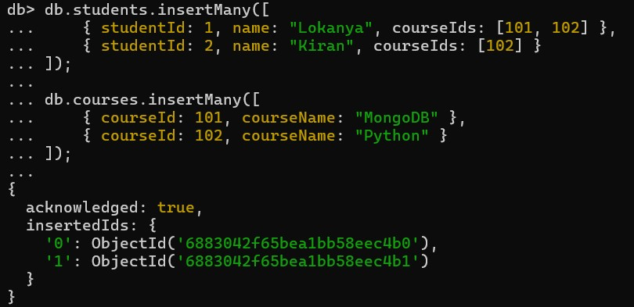
Aggregation with $lookup:
db.students.aggregate([
{
$lookup: {
from: "courses",
localField: "courseIds",
foreignField: "courseId",
as: "enrolledCourses"
}
}
]).pretty();
